MINDSET QUIZ

1. Circle the number for each question which best describes you
2. Total and record your score when you have completed each of the 10 questions
3. Using the SCORE chart, record your mindset

**Disagree**

**Strongly Agree**

**Agree Disagree Strongly**

|  |  |  |  |  |
| --- | --- | --- | --- | --- |
| Your intelligence is something very basic about you that you can’t change very much | 0 | 1 | 2 | 3 |
| No matter how much intelligence you have, you can always change it quite a bit | 3 | 2 | 1 | 0 |
| Only a few people will be truly good at sports, you have to be born with the ability | 0 | 1 | 2 | 3 |
| The harder you work at something, the better you will  be | 3 | 2 | 1 | 0 |
| I often get angry when I get feedback about my performance | 0 | 1 | 2 | 3 |
| I appreciate when people give me feedback about my  performance | 3 | 2 | 1 | 0 |
| Truly smart people do not need to try hard | 0 | 1 | 2 | 3 |
| You can always change how intelligent you are | 3 | 2 | 1 | 0 |
| You are a certain kind of person and there is not much that can be done to really change that | 0 | 1 | 2 | 3 |
| An important reason why I do my school work is that I enjoy learning new things | 3 | 2 | 1 | 0 |

# SCORE CHART

**22-­‐30 =** Strong Growth Mindset

**17-­‐21 =** Growth with some Fixed ideas **11-­‐16 =** Fixed with some growth ideas **0-­‐10 =** Strong fixed mindset

# MY SCORE:

**MY MINDSET:**

Adapted from: Dweck, C. S. (2006). *Mindset: The new psychology of success*. New York: Random House Inc.

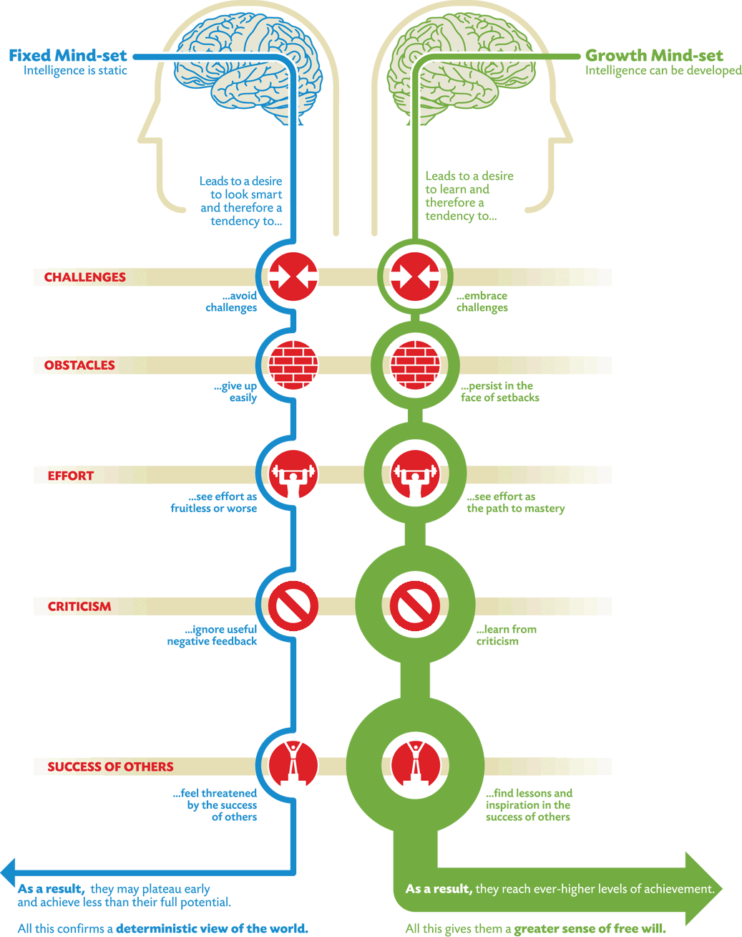

Source: [**https://www.mindsetworks.com/science/Impact**](https://www.mindsetworks.com/science/Impact)

**How to Change Your Mindset**

*There are eight general approaches for developing the foundation for such a mindset:*

1. Create a new compelling belief: a belief in yourself, in your own skills and abilities, and in your capacity for positive change.
2. View failure in a different light: see failure as an opportunity to learn from your experiences and apply what you have learned next time around.
3. Cultivate your [self-awareness](https://positivepsychology.com/self-awareness-matters-how-you-can-be-more-self-aware/): work on becoming more aware of your talents, strengths, and weaknesses; gather feedback from those who know you best and put it together for a comprehensive view of yourself.
4. Be curious and commit to lifelong learning: try to adopt the attitude of a child, looking at the world around you with awe and wonderment; ask questions and truly listen to the answers.
5. Get friendly with challenges: know that if you mean to accomplish anything worthwhile, you will face many challenges on your journey; prepare yourself for facing these challenges, and for failing sometimes.
6. Do what you love and love what you do: it’s much easier to succeed when you are passionate about what you’re doing; whether you cultivate love for what you already do or focus on doing what you already love, developing passion is important.
7. Be tenacious: it takes a lot of hard work to succeed, but it takes even more than working hard—you must be tenacious, weathering obstacles and getting back up after each time you fall.
8. Inspire and be inspired by others: it can be tempting to envy others when they succeed, especially if they go farther than you, but it will not help you to succeed; commit to being an inspiration to others and use the success of others to get inspiration as well (Zimmerman, 2016).